

**INDIVIDUAL ASSIGNMENT**

**TECHNOLOGY PARK MALAYSIA**

**CT108-3-1-PYP**

**PYTHON PROGRAMMING**

**APDF1F2109PE, APU1F2109IT, APU1F2109MMT, APU1F2109PE, APU1F2109SE, APU1F2109TE, APU1F2109ME, APD1F2109IT, APD1F2109CE, APD1F2109EEE, APD1F2109ME, APU1F2109EEE, APU1F2109CE, APU1F2109CGD, APD1F2109CGD, APD1F2109TE, APD1F2109SE, APD1F2109MMT**

**HAND OUT DATE: 31st OCTOBER 2021**

**HAND IN DATE: 12th DECEMBER 2021**

**WEIGHTAGE: 100%**

**STUDENT NAME: TULEUSHOV ANUARBEK**

**TP NUMBER: TP059399**

**INSTRUCTIONS TO CANDIDATES:**

1. Submit your assignment online in Moodle Folder unless advised otherwise
2. Late submission will be awarded zero (0) unless Extenuating Circumstances (EC) are upheld
3. Cases of plagiarism will be penalized
4. You must obtain at least 50% in each component to pass this module

Table of contents

**Introduction** 3

1.0 Design of Pseudocode 4

2.0 Design of Program – Flowchart 27

3.0 Program Source Code 49

3.1 Variable 49

3.2 Operator 50

3.2.1 Arithmetical Operator 50

3.2.2 Assignment Operator 51

3.2.3 Comparison Operator 51

3.2.4 Logical Operator 51

3.3 Control Structure 52

3.4 Functions 53

3.5 File 55

3.5.1 Read 55

3.5.2 Append 55

3.5.3 Write 55

3.6 Module 56

4.0 Sample of Input and Output 56

4.1 Menu – User 56

4.2 Menu – Stuff 58

4.3 Menu – Admin 59

# **Introduction**

# 1.0 Design of Pseudocode

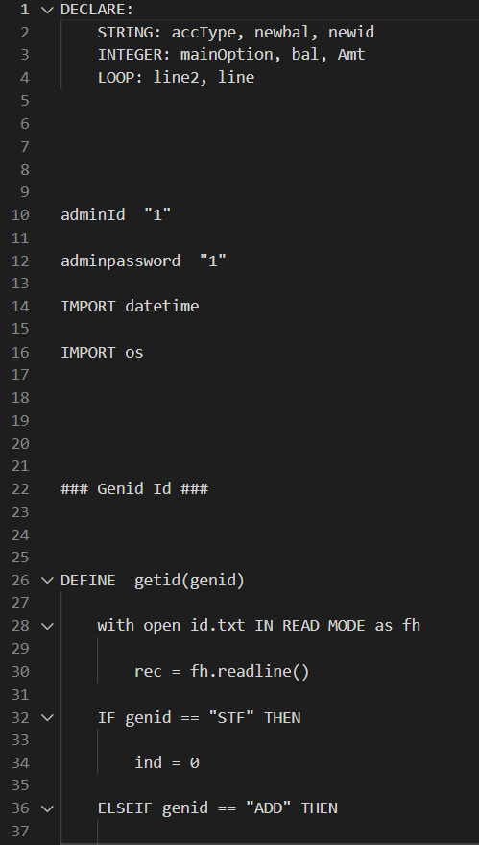

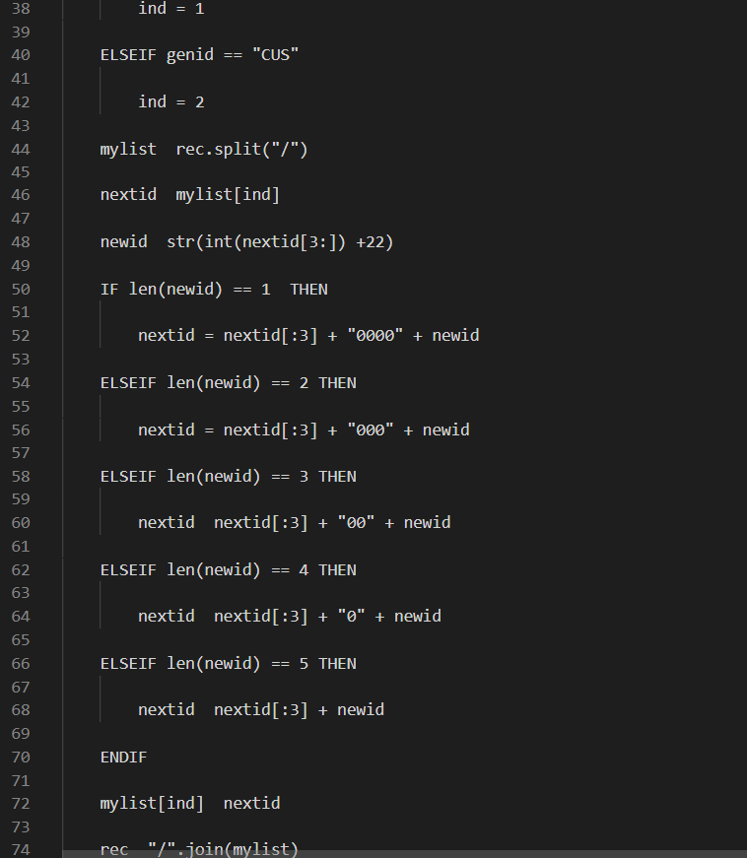

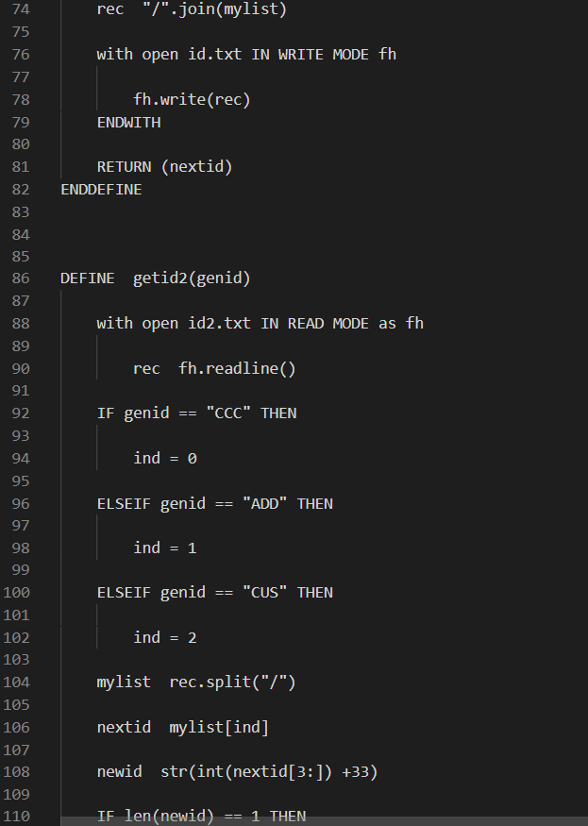

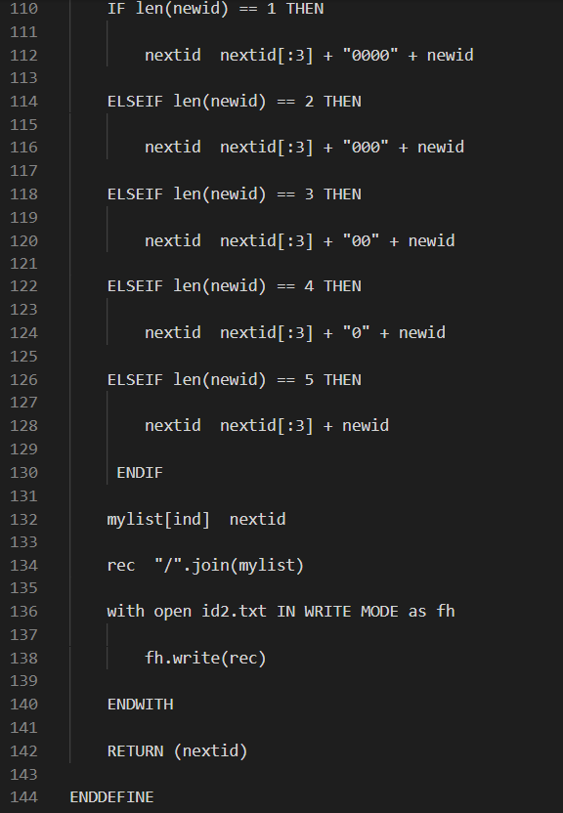

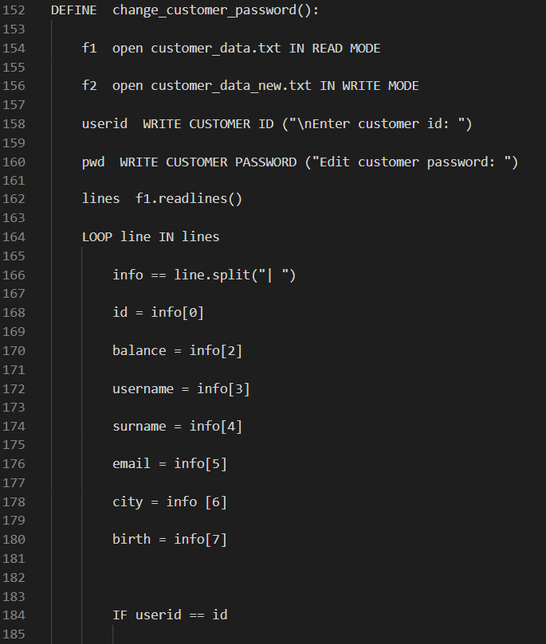

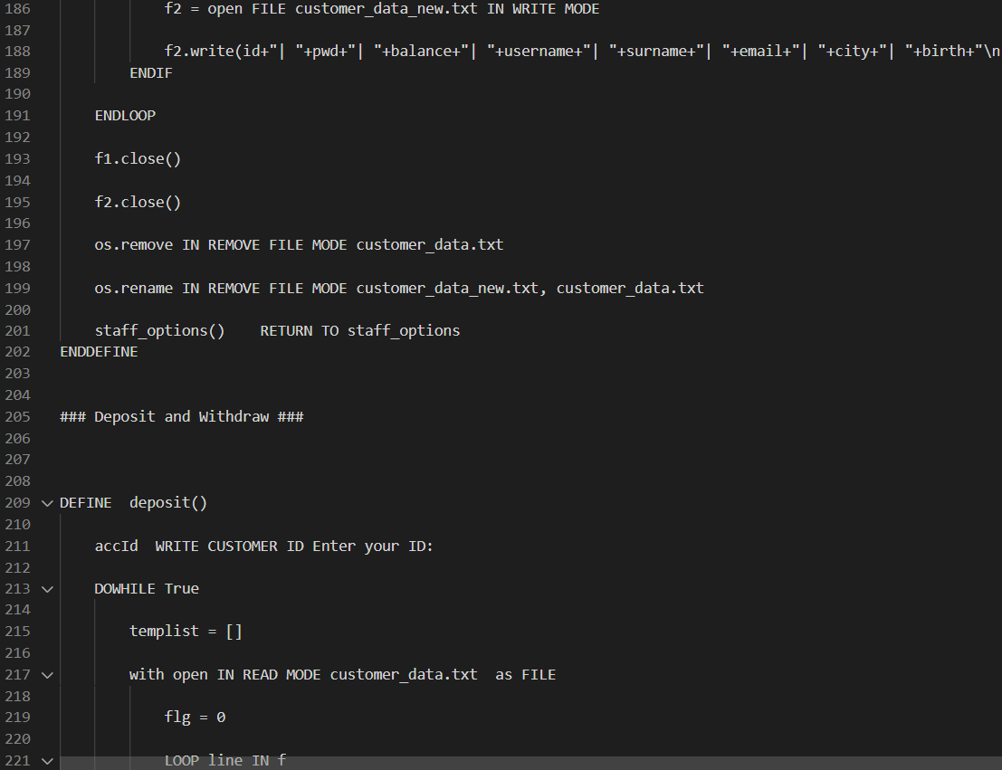

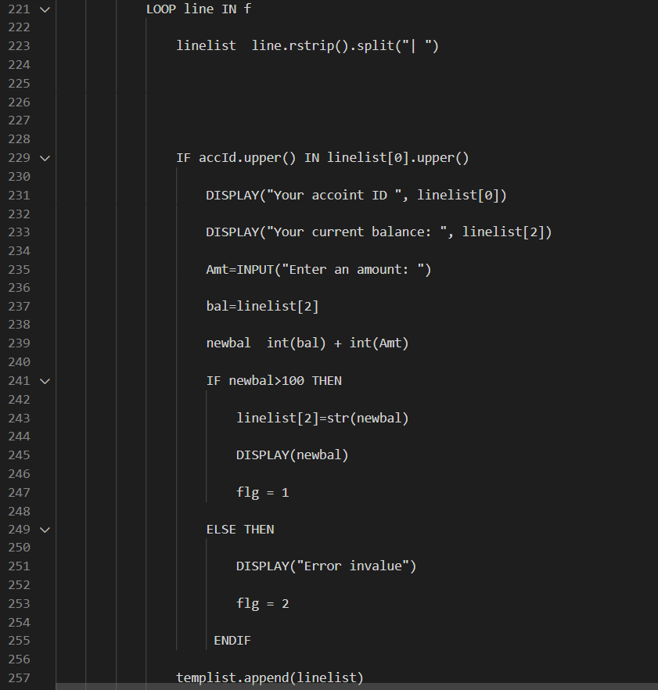

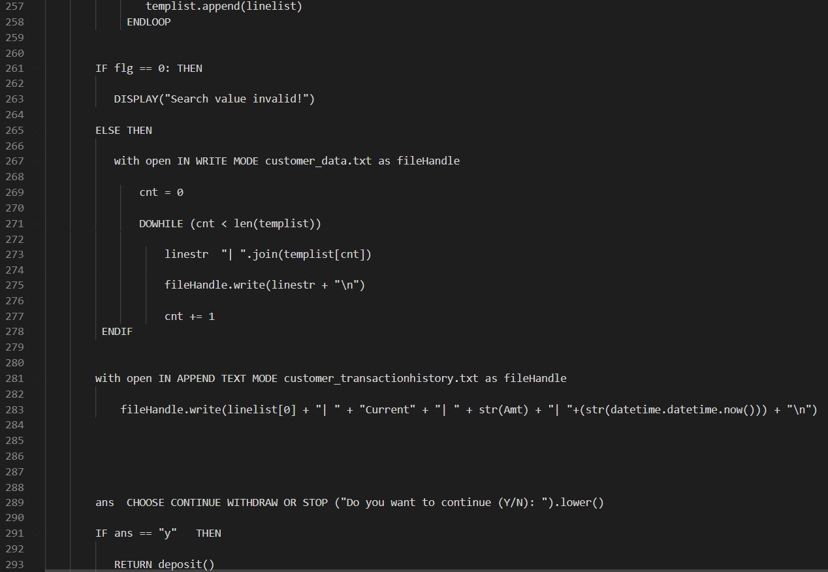

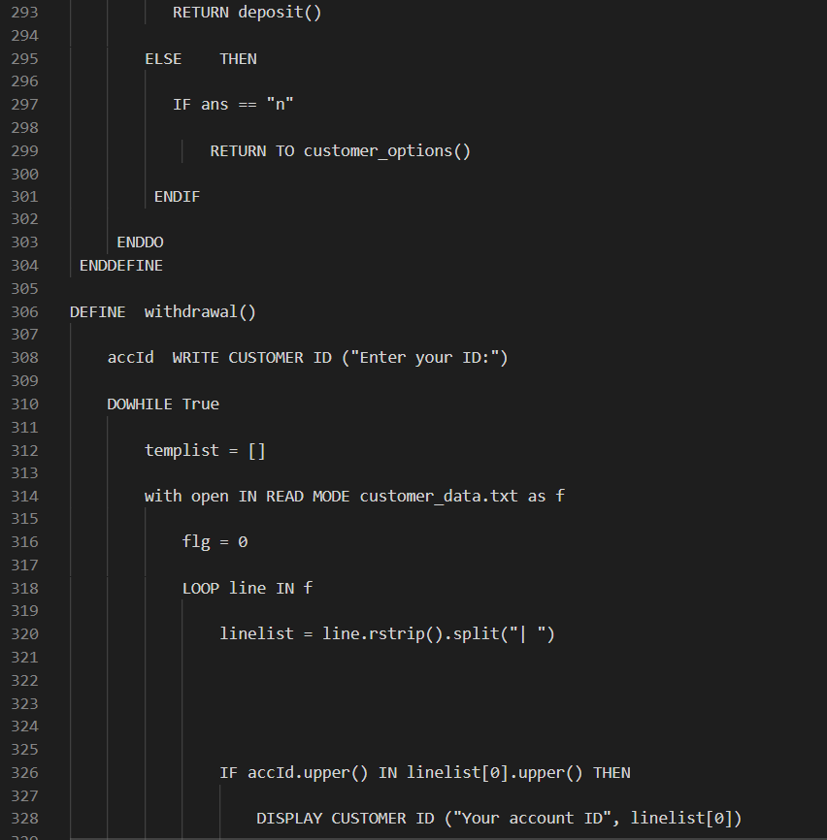

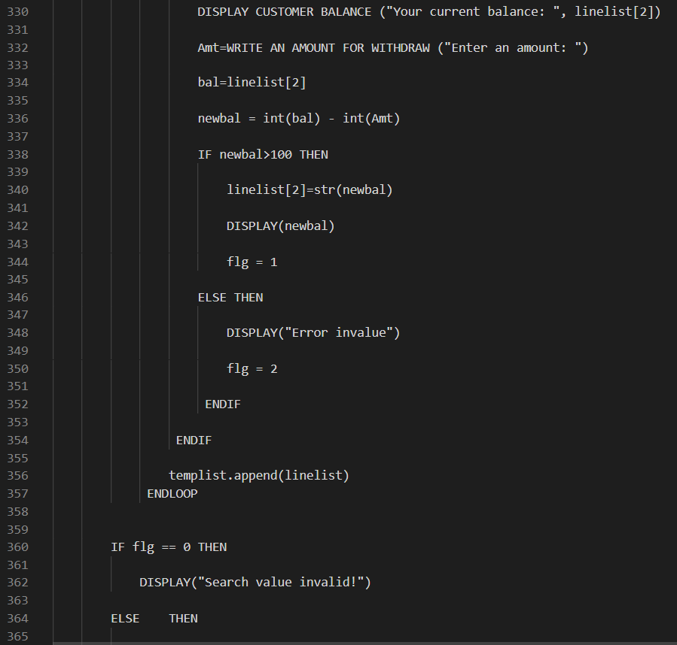

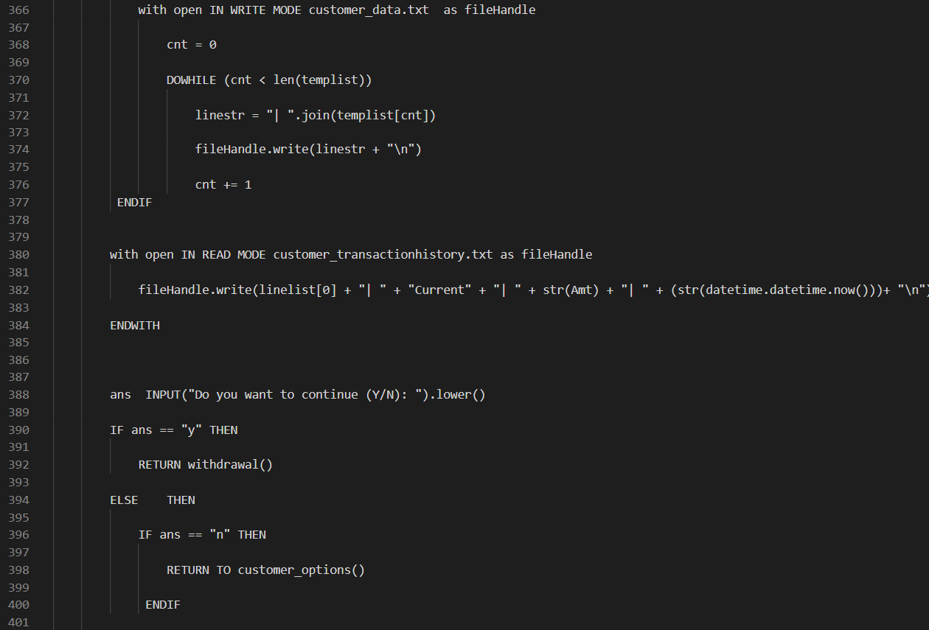

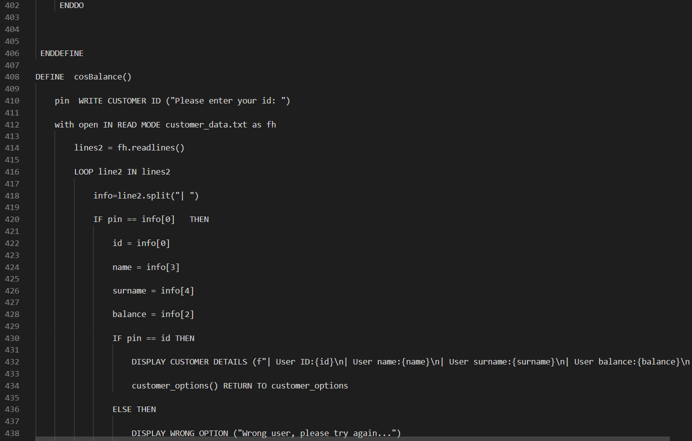

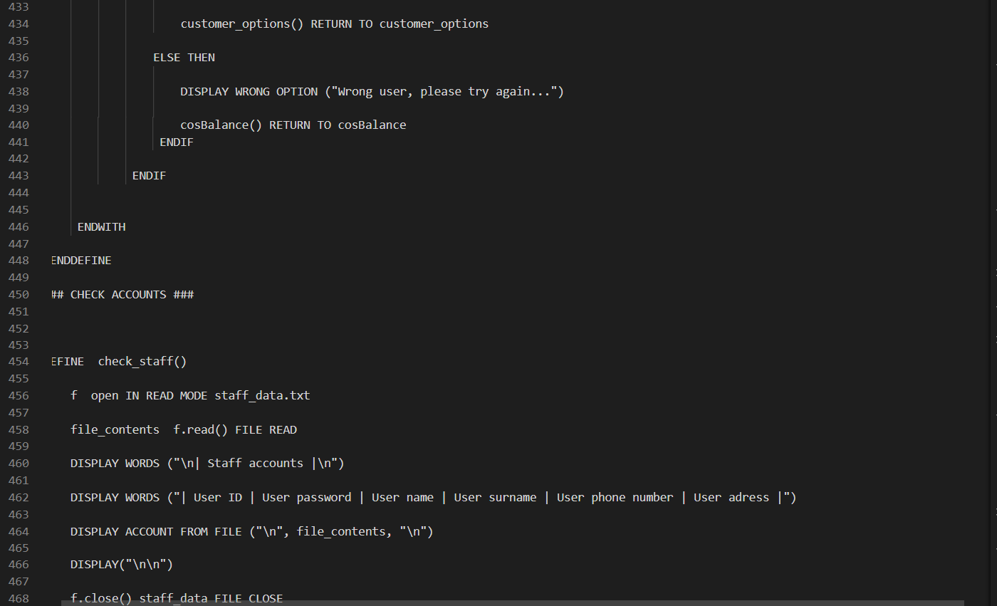

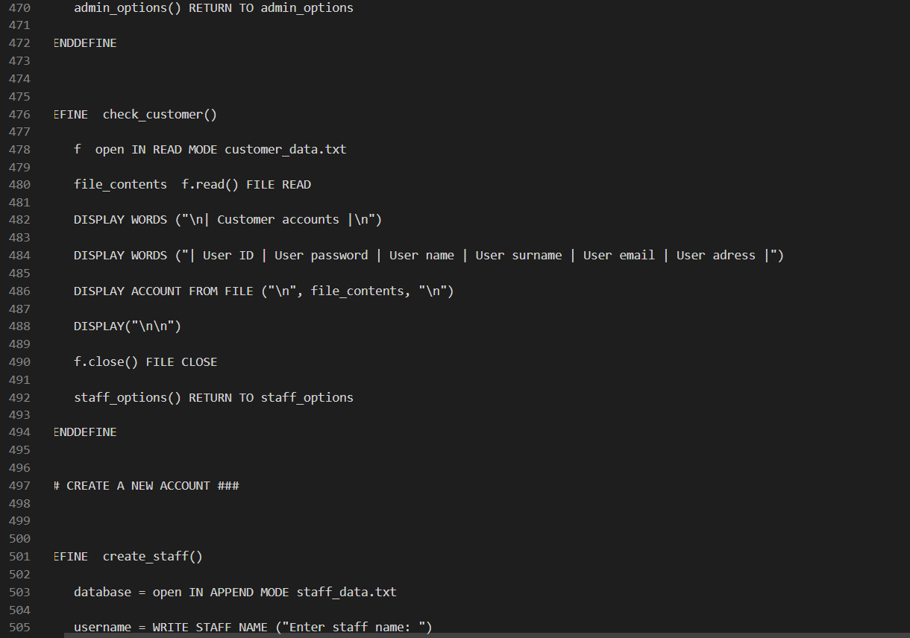

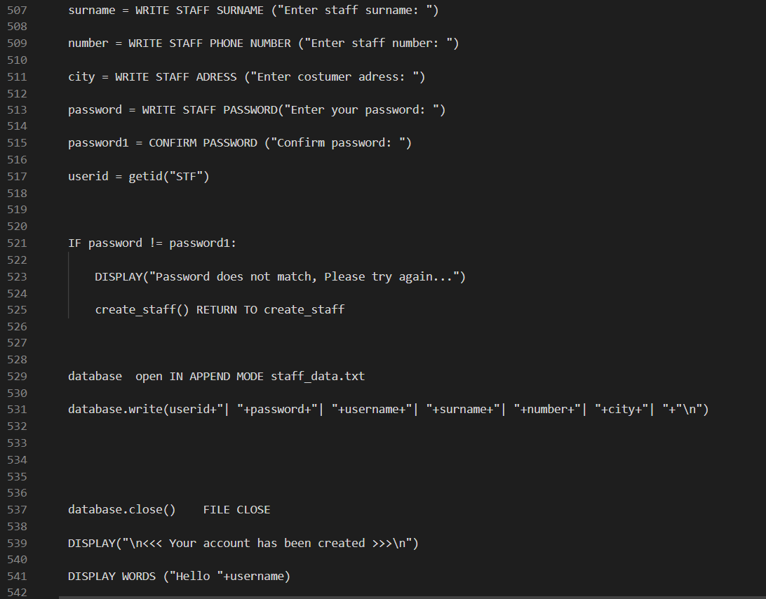

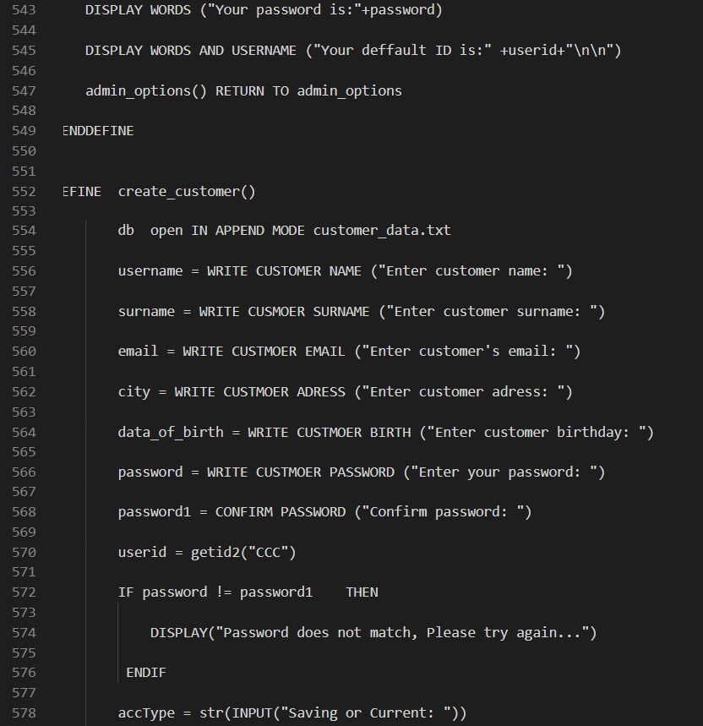

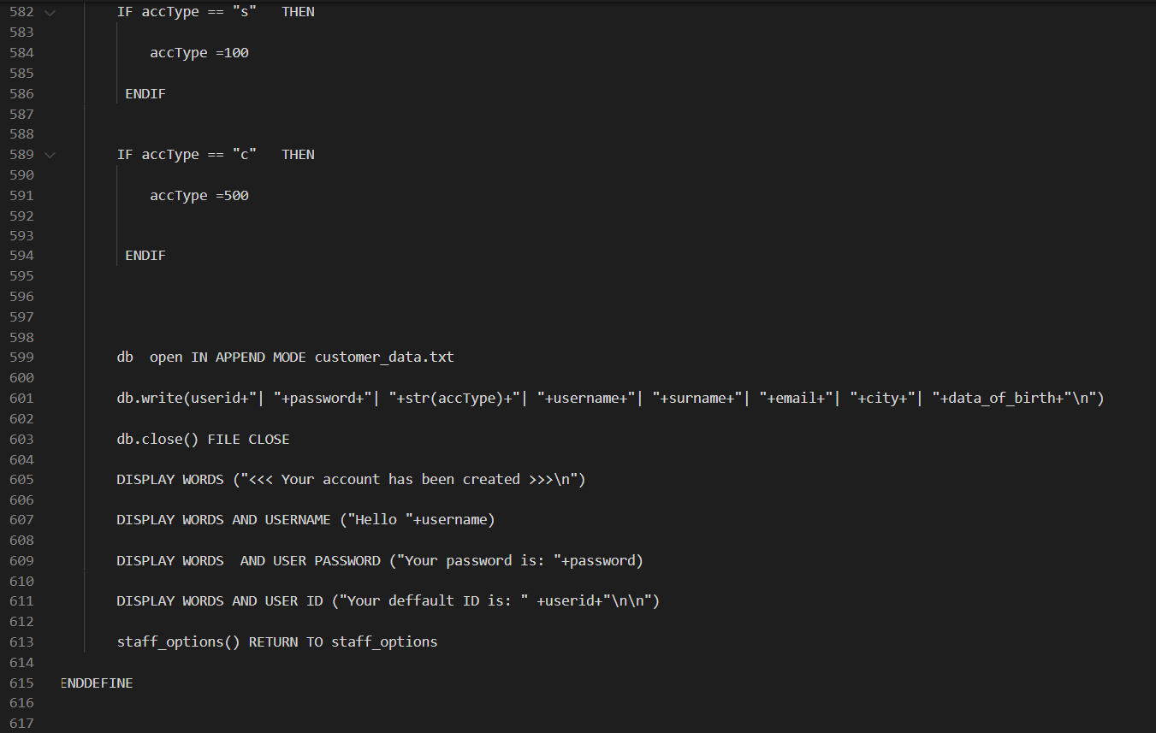

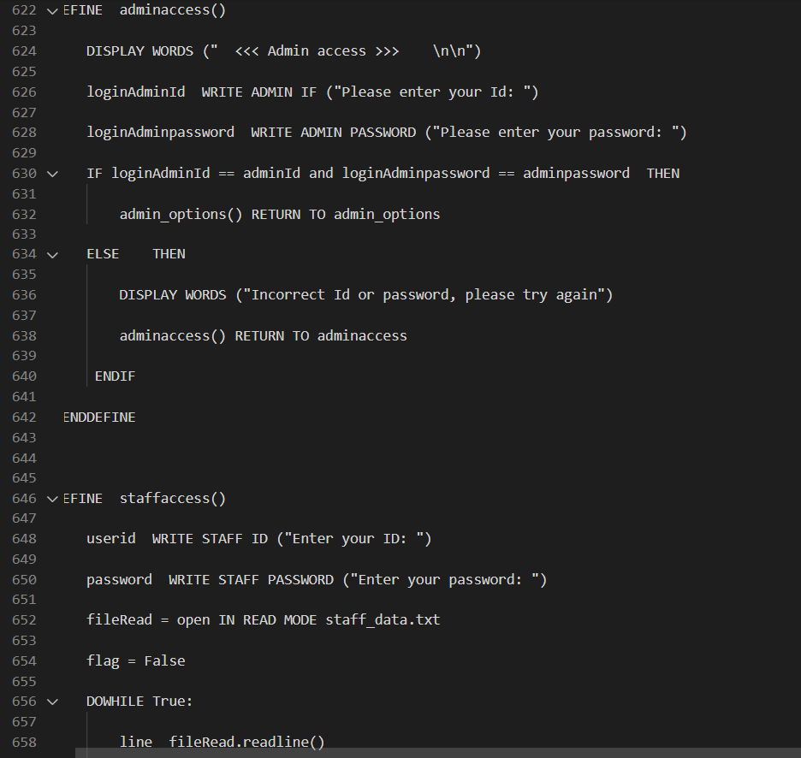

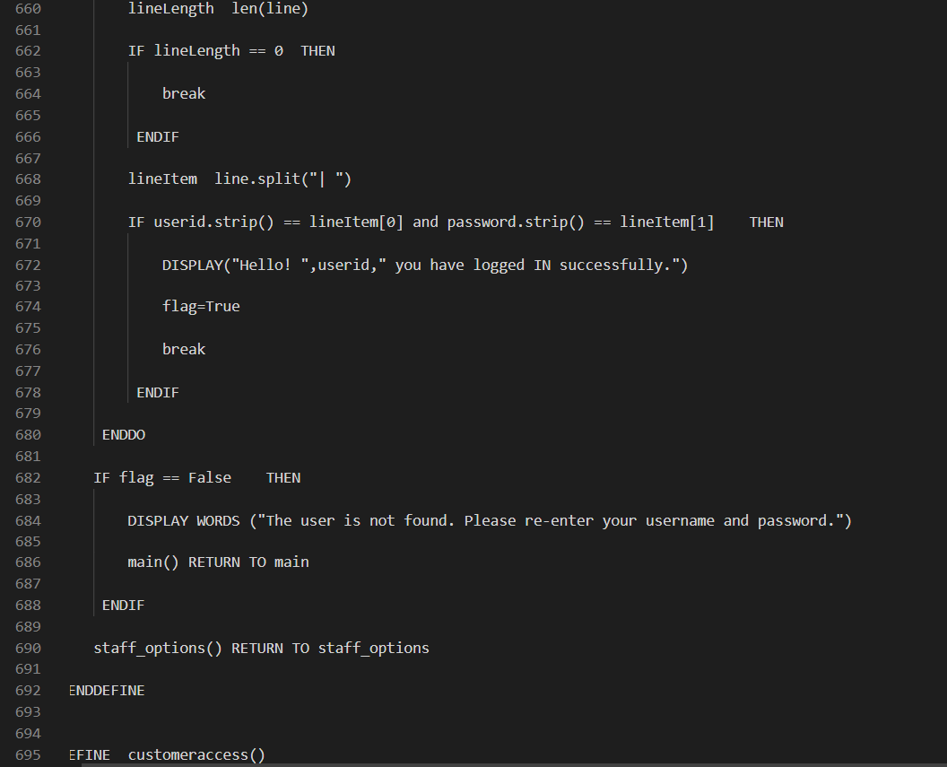

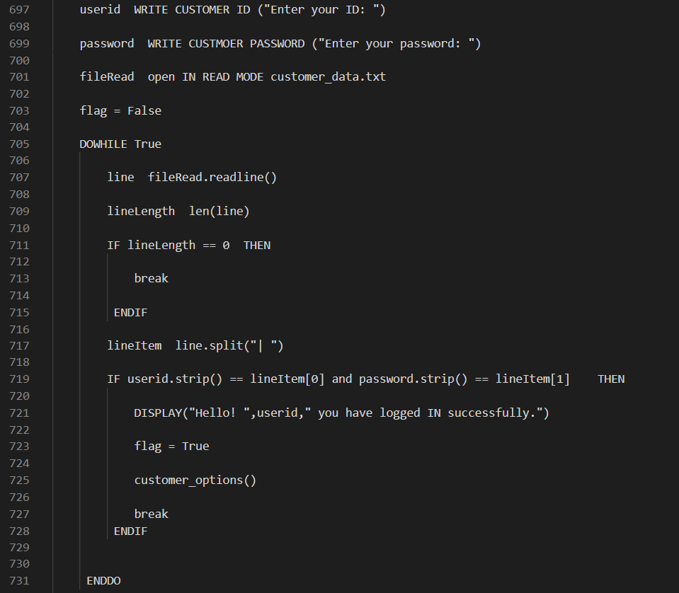

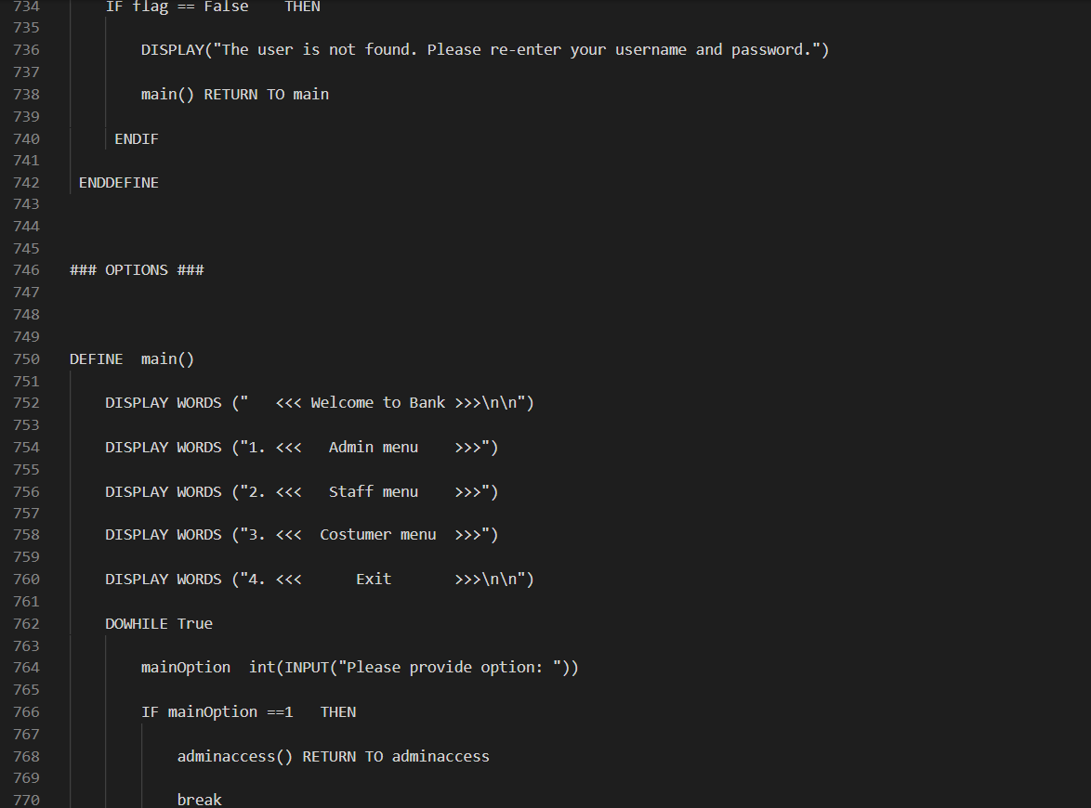

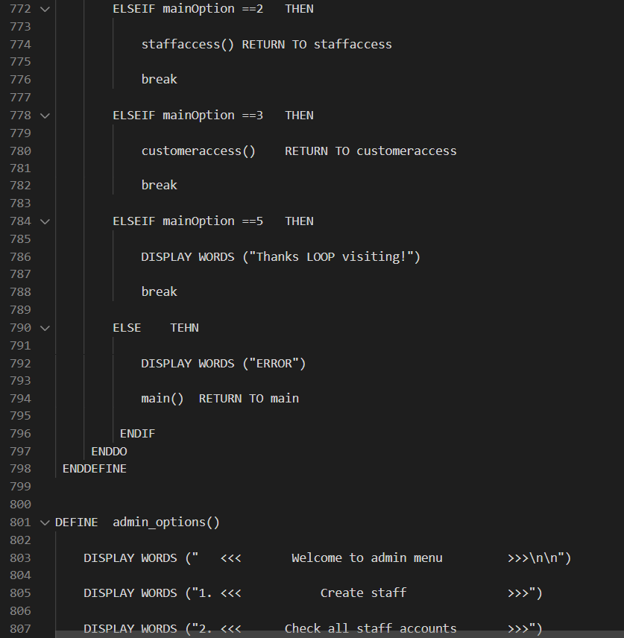

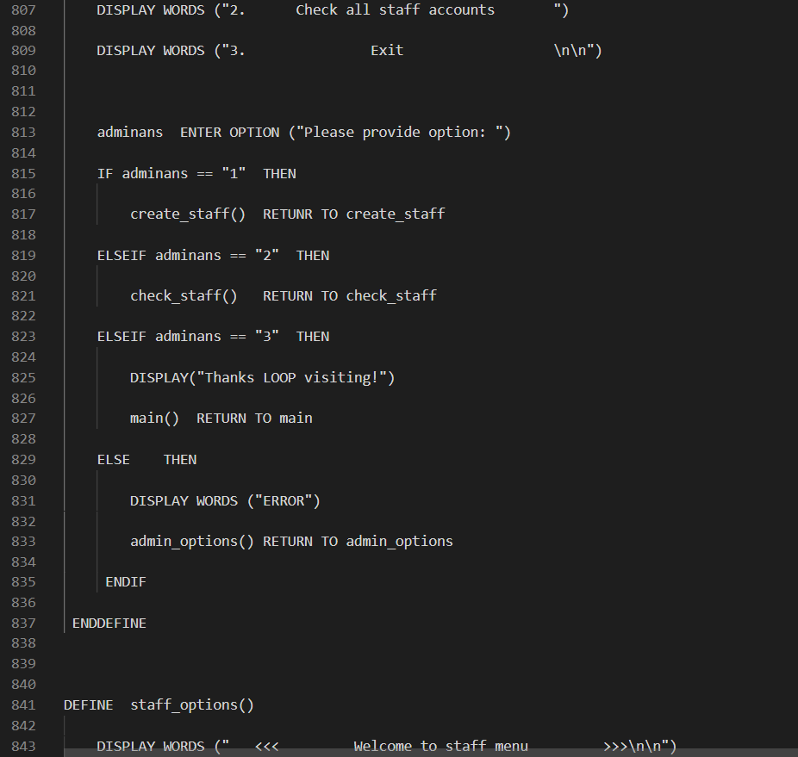

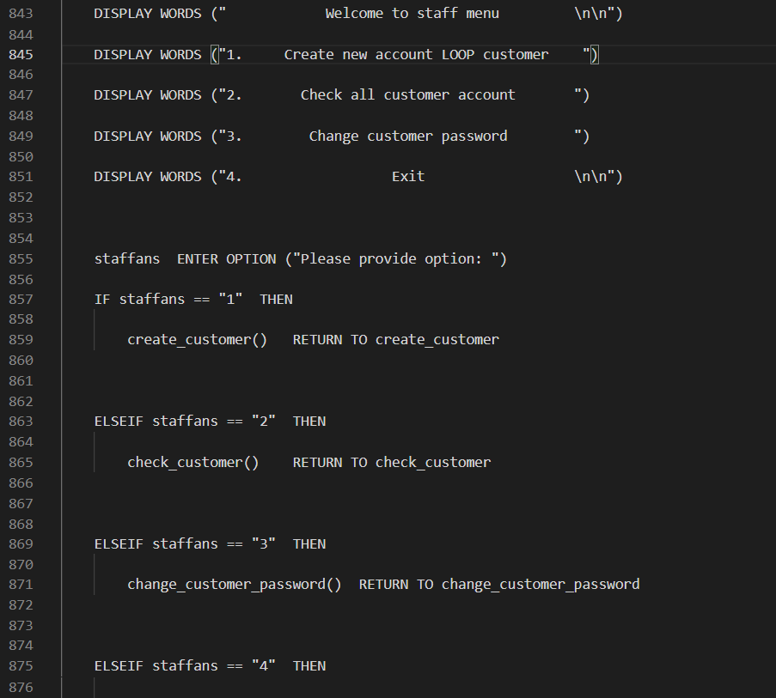

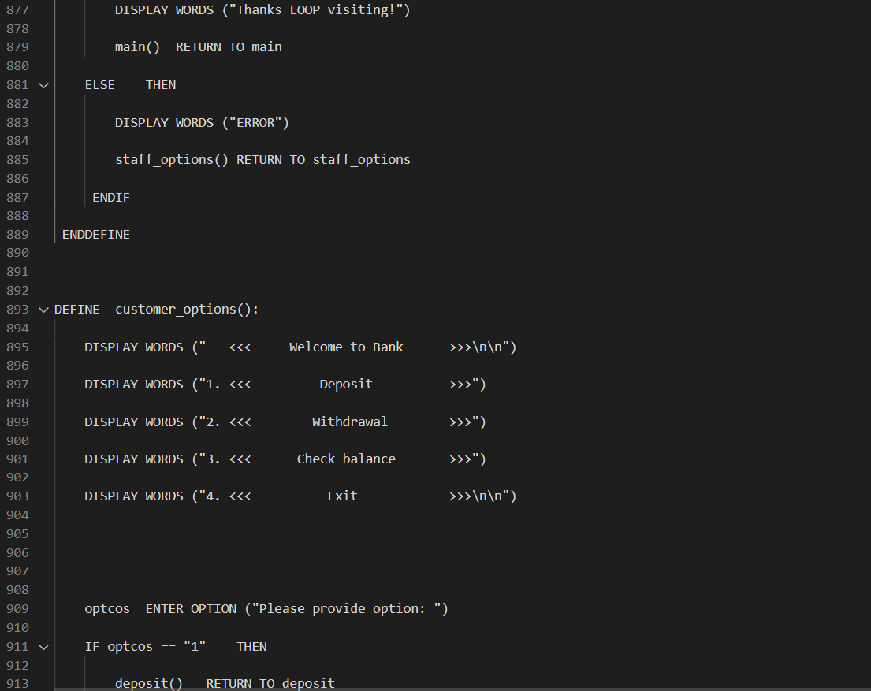

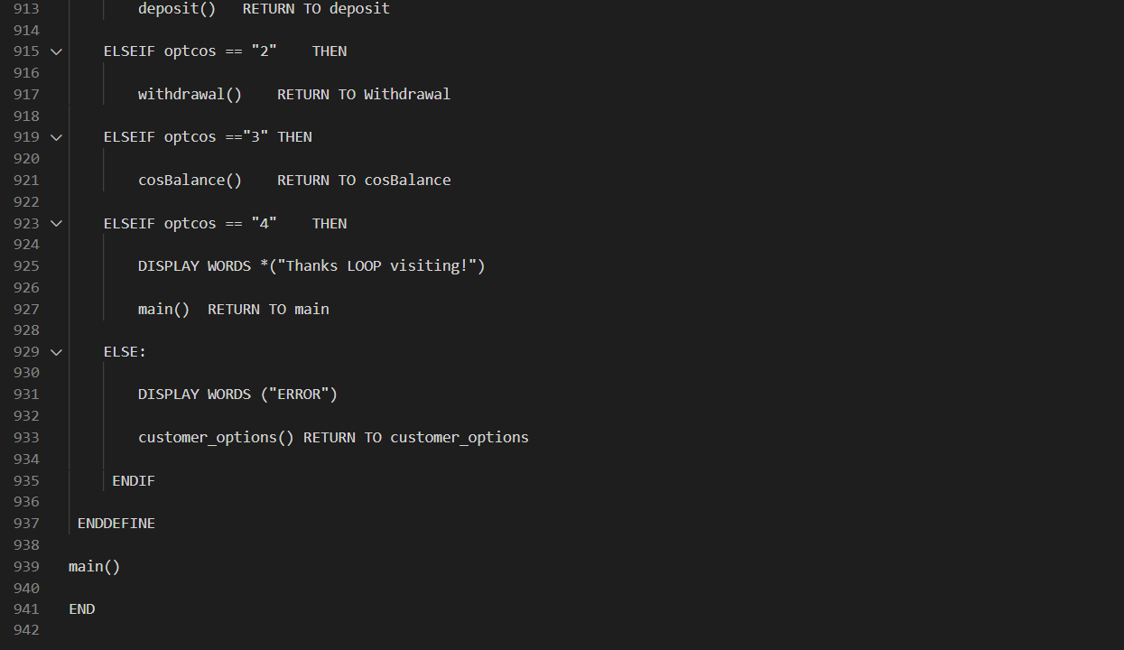

# 2.0 Design of Program – Flowchart

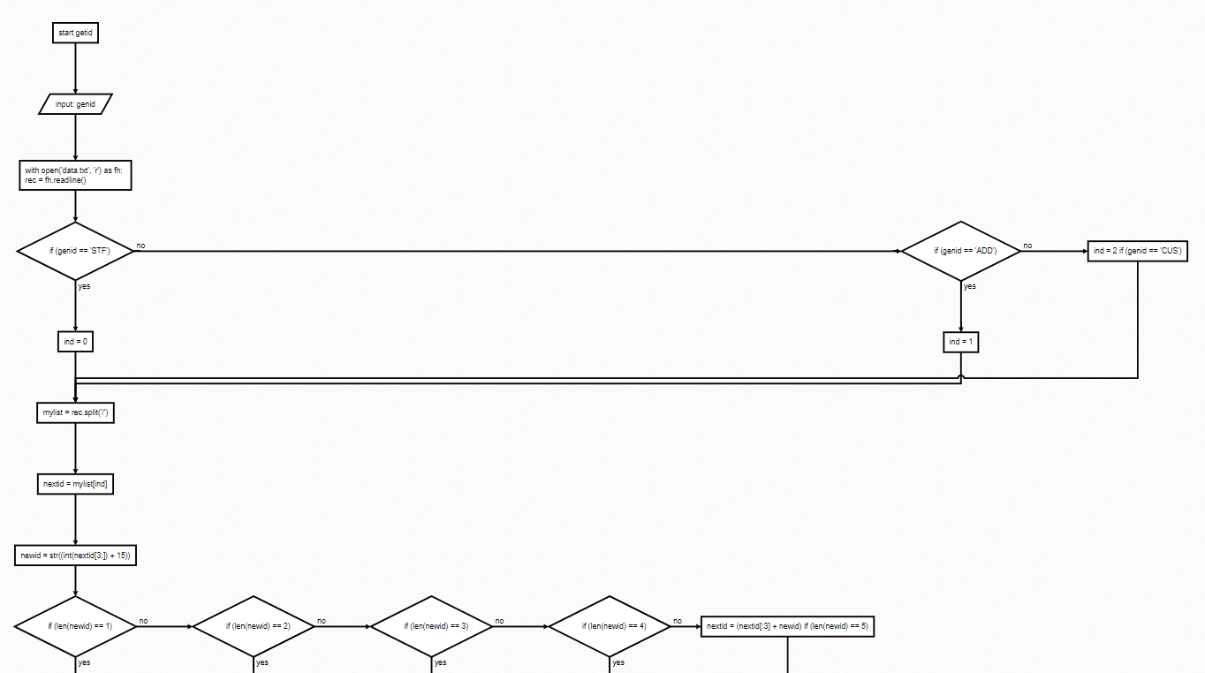

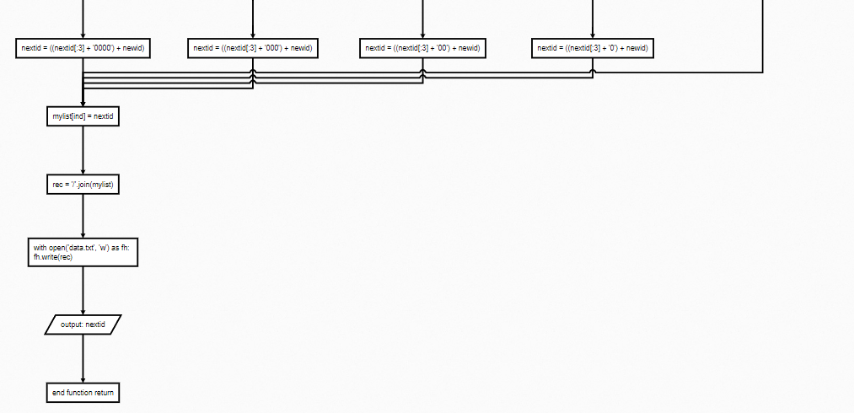

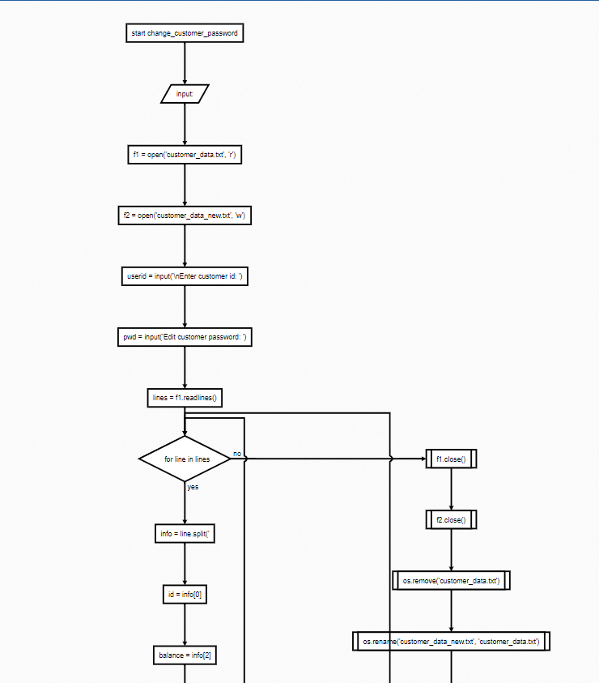

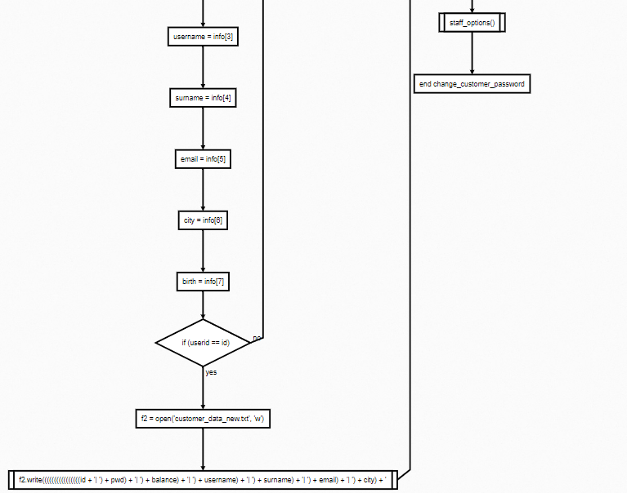

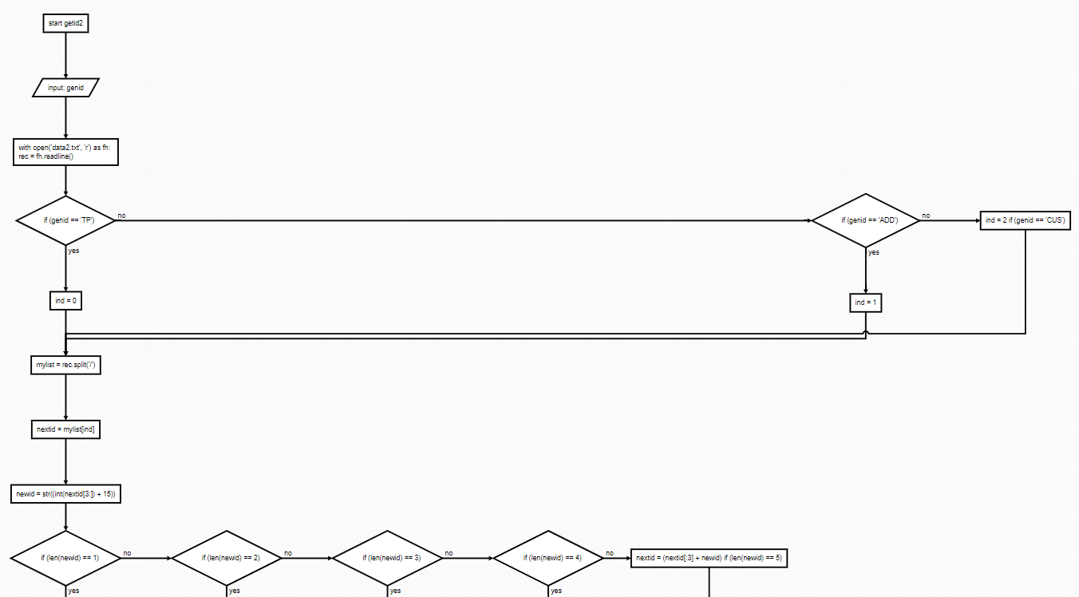

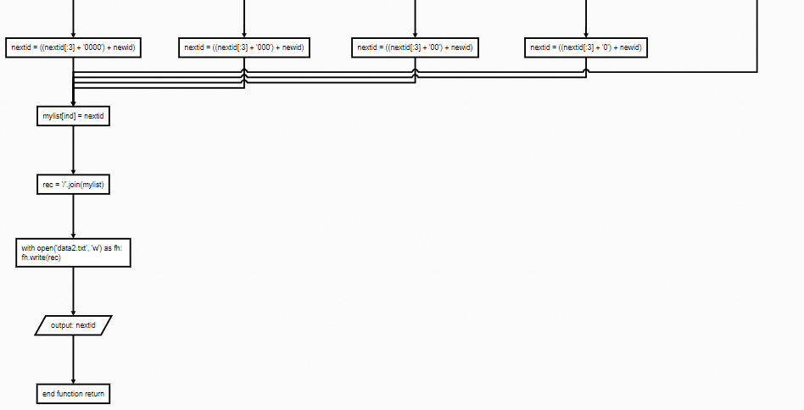

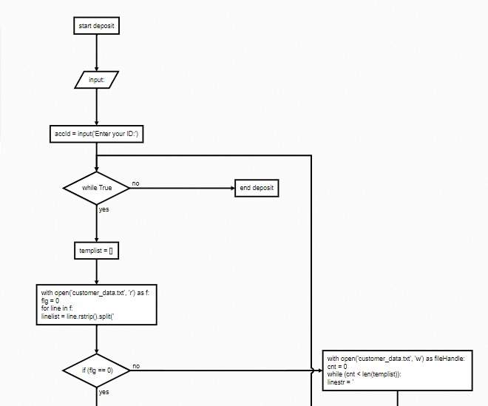

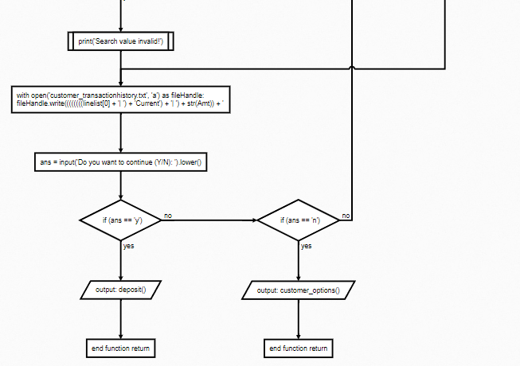

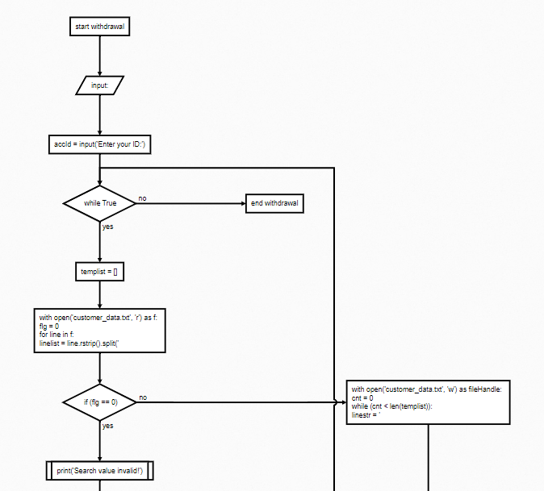

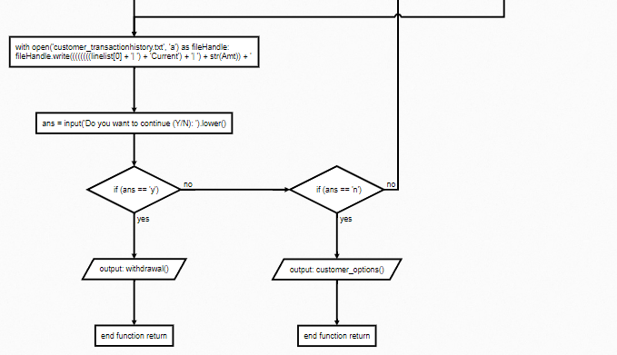

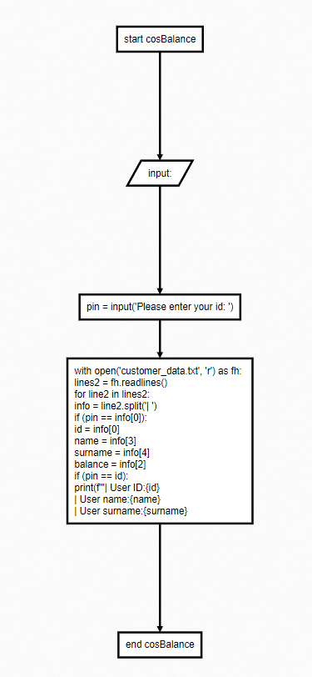

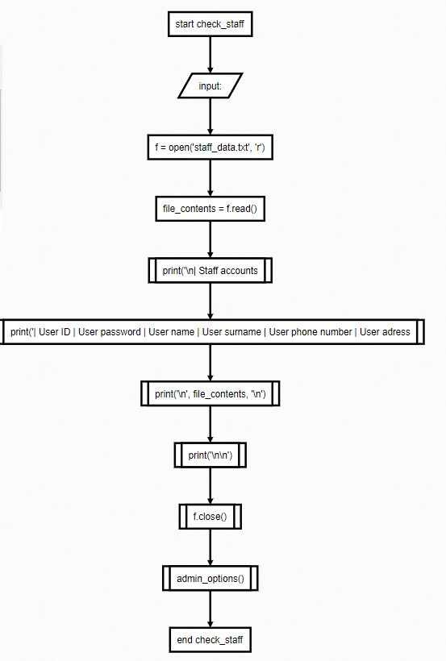

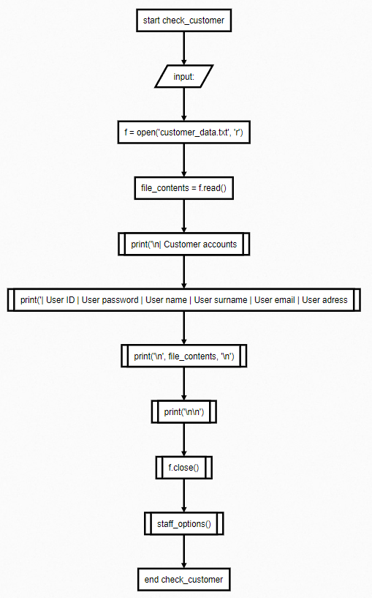

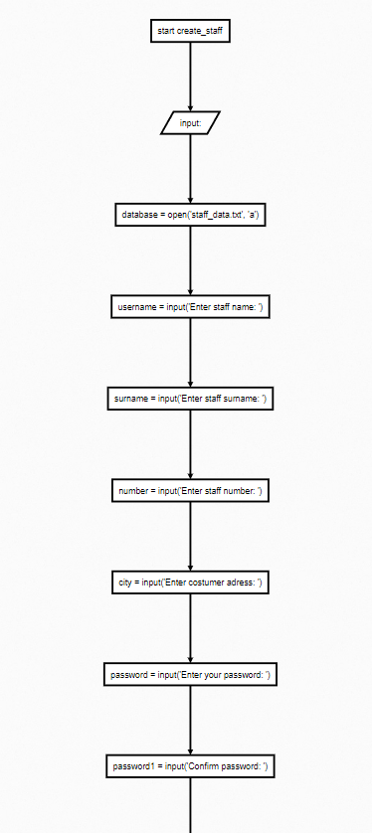

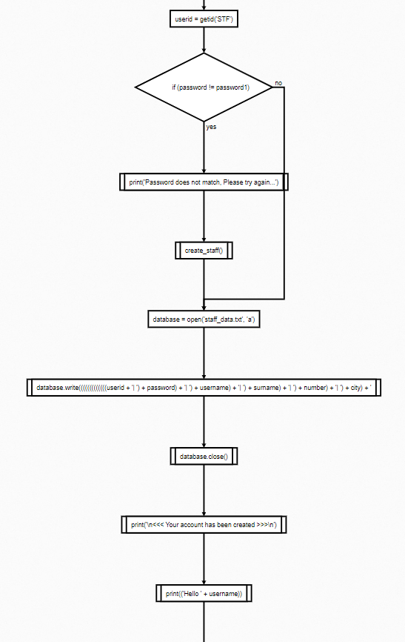

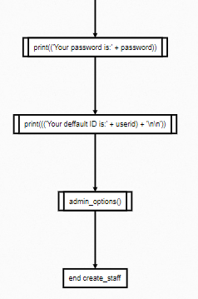

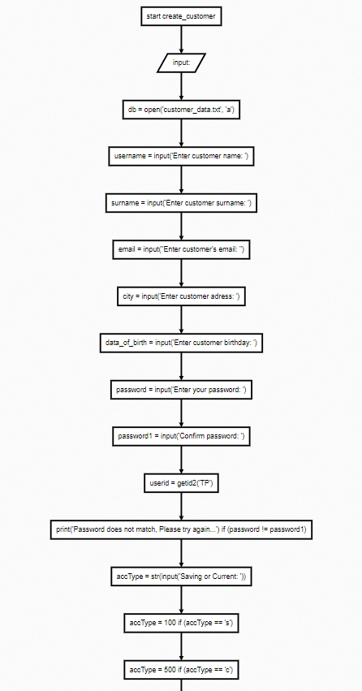

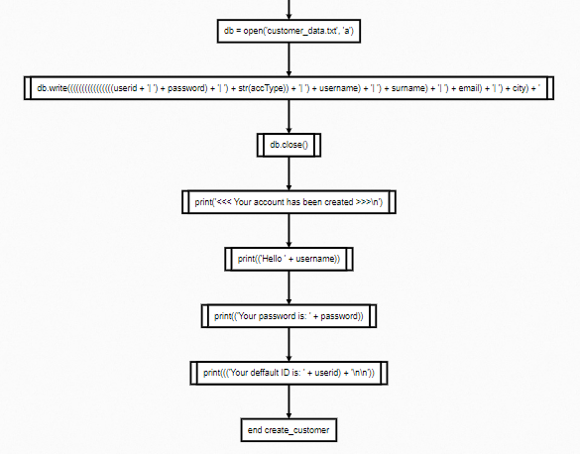

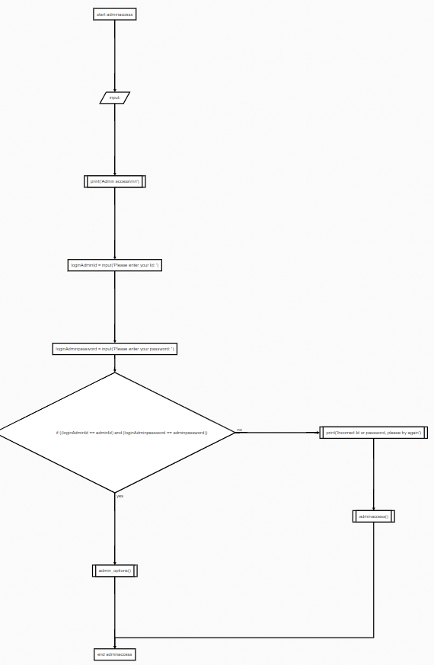

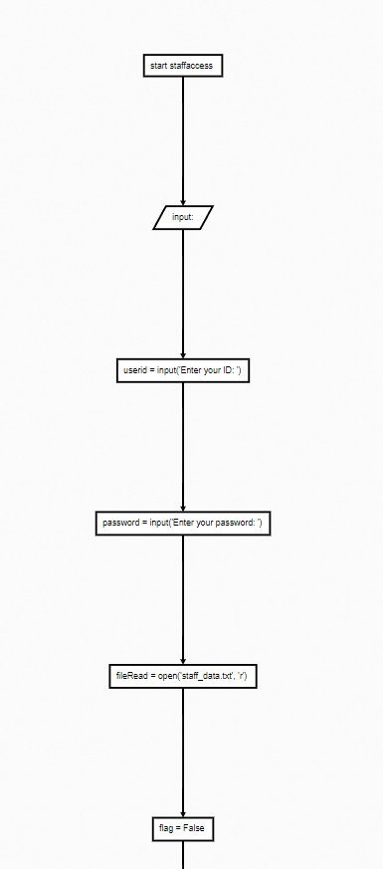

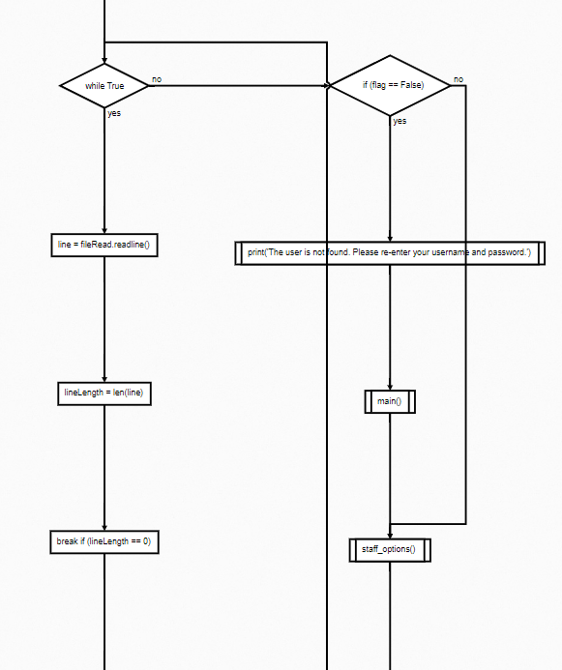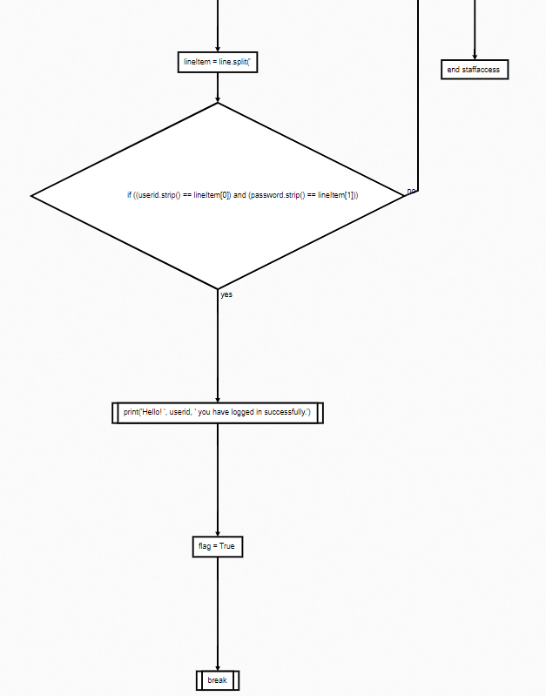

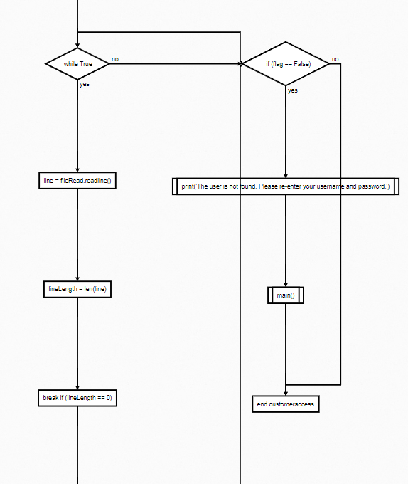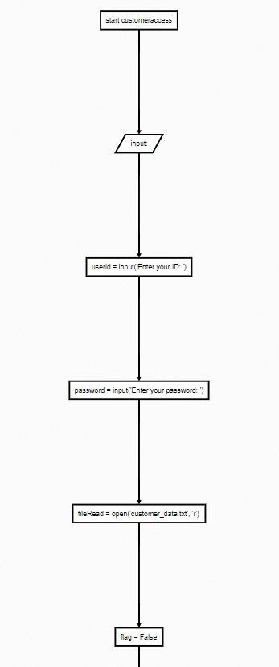

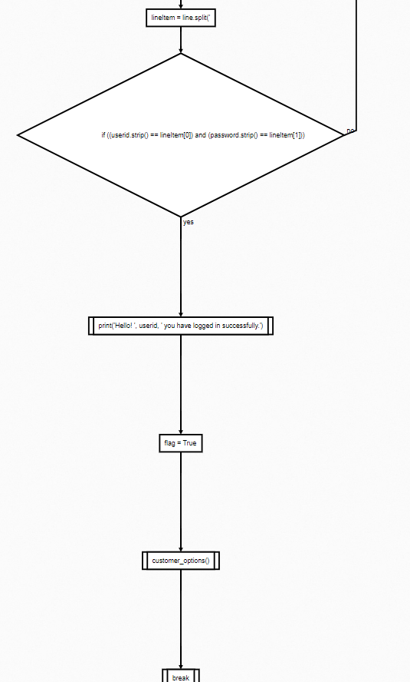

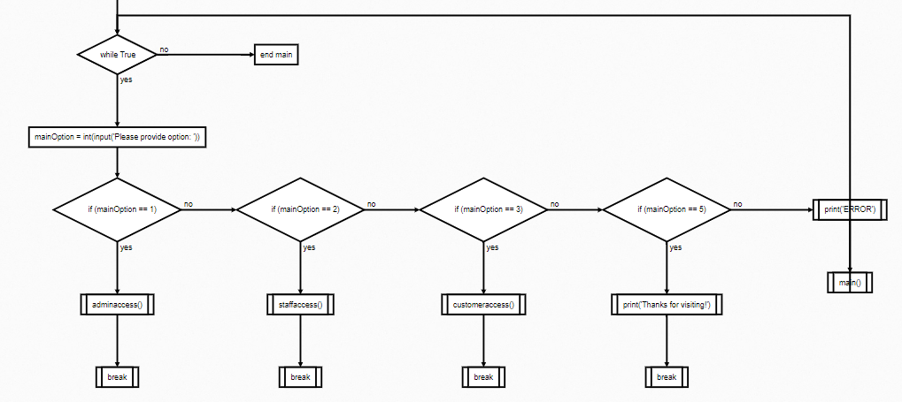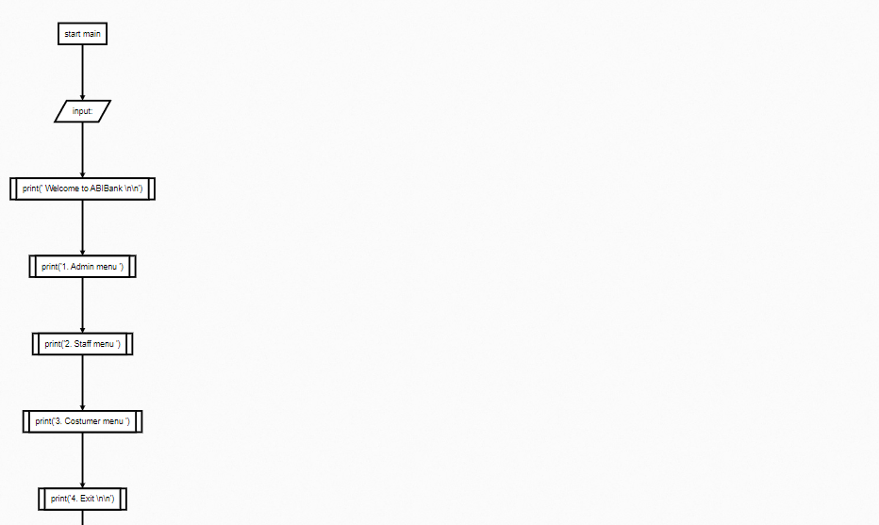

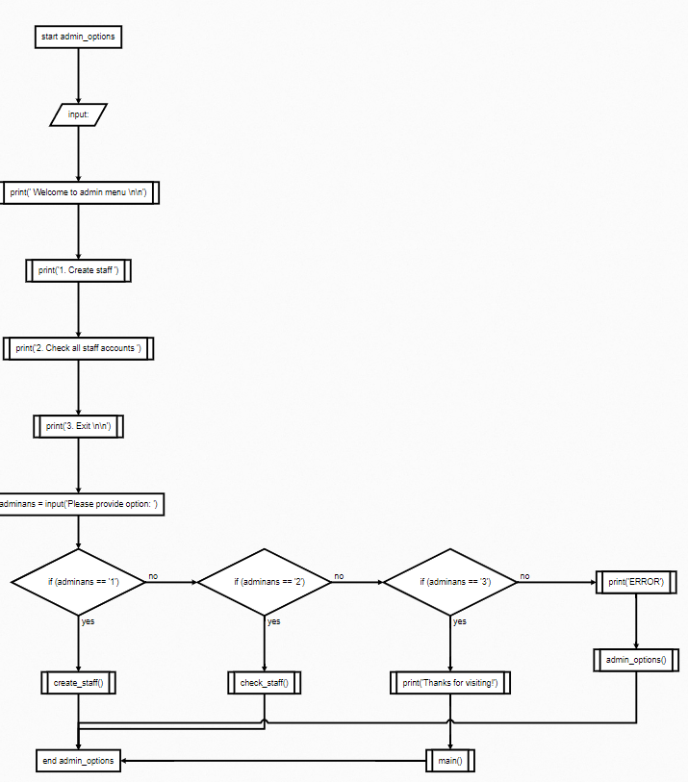

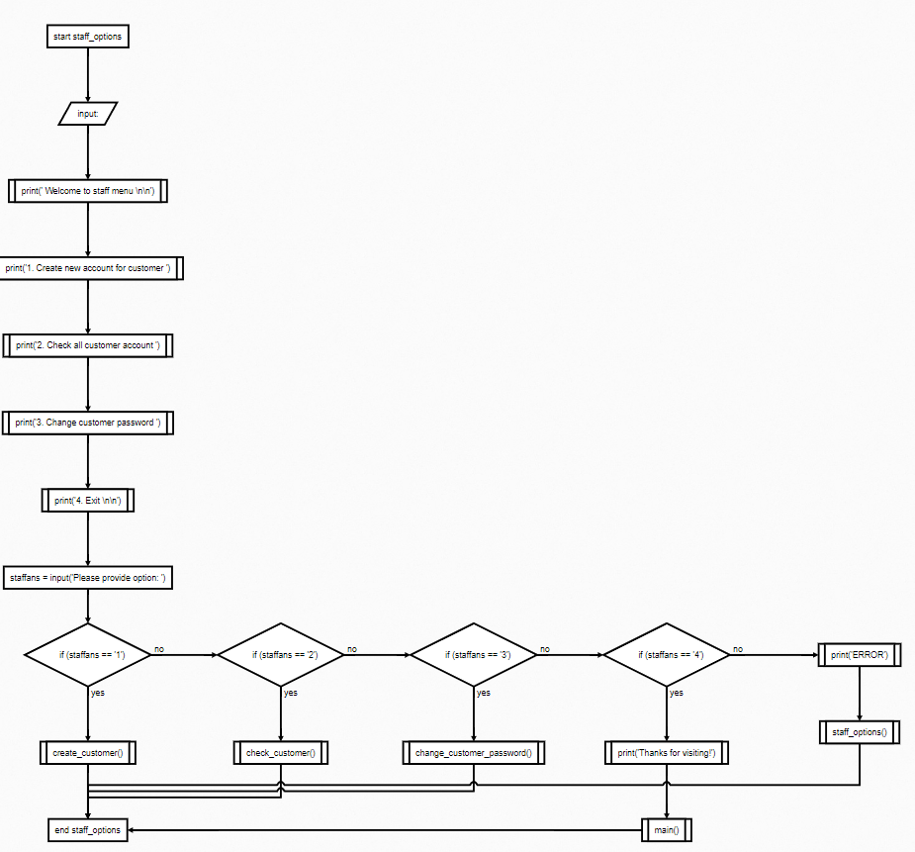

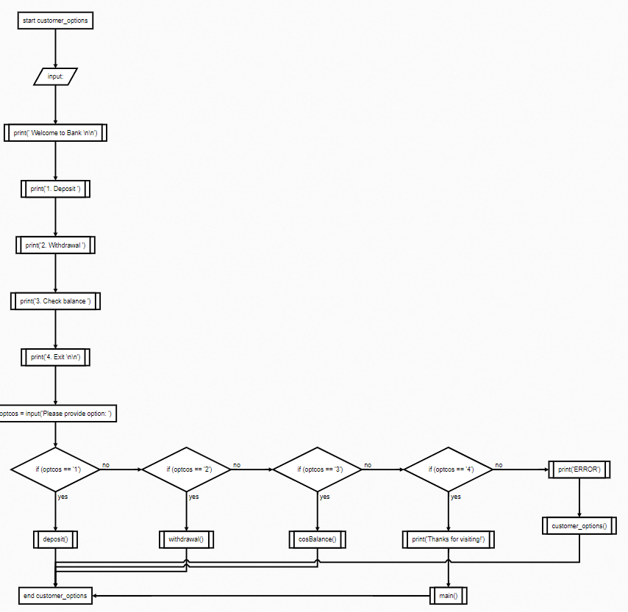

# 3.0 Program Source Code

The source code of a programmer is the most essential component of a computer programme. It can be read and comprehended by a human being. When a programmer types a series of C programming language commands into Windows Notepad and saves the sequence as a text file, the source code is said to be present.

Source code and object code are the "before" and "after" forms of a created computer programme, respectively. Because there is only one version of the code, the terms source code and object code do not apply to script (noncompiled or interpreted) programming languages like JavaScript.

A text editor, a visual programming tool, or an integrated development environment (IDE) like the software development kit can all be used to create source code (SDK). In large software development environments, there are several management tools that help programmers separate their tasks.

## 3.1 Variable

Variable (from the English variable) is a named or otherwise addressable memory area that can be used to access data. Sounds complicated and scary, doesn't it? However, in practice, your child will not need such a definition. At least at the initial stages of learning programming.

In simple words, a variable is a data store. You can put some value here (for example, a number, a string, or another data type). An even simpler way to imagine a variable is to think about what surrounds us. For example, the variable may be some small bag where you can put, for example, an apple. It will be there until we decide to do something with the apple.

A variable must be declared in any program. That is, to get this bag before putting an apple in it. In modern applications, there can be as many variables as you want. For example, an apple is stored in one bag, and a candy is stored in another.

#### 3.1.1 String





In this two images string helps create new/next id adding +15 to each line.

#### 3.1.2 Integer





.In this two images integer allows the variable “mewbal” to count amounts of given number.

#### 3.1.3 Boolean

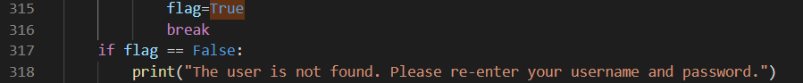

In this image the variable “flag” have the Boolean value of “True” and “False”. This value is useful for the determine the next command.

## 3.2 Operator

An operator is a symbol in computer programming that frequently symbolises an action or process. These symbols were created using mathematical and logical symbols. A programme that can alter a value or operand is known as an operator.

### 3.2.1 Arithmetical Operator

##### Addition



A mathematical function that performs a computation on two operands is known as an arithmetic operator. They're common in ordinary math, and most programming languages have a set of them that may be used in equations to do a variety of sequential operations.

##### Modules





Modular programming is the construction of a programme as a collection of tiny independent components called modules, each having its own structure and behaviour. Modular development makes testing and identifying software flaws a breeze.

#### Multiplication

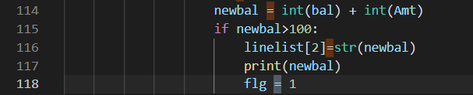

Two integers are multiplied. The basic arithmetic operations of addition, subtraction, multiplication, and division are supported by all computer languages.

### 3.2.2 Assignment Operator

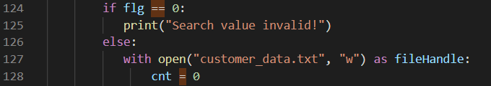

### 3.2.3 Comparison Operator

#### Equal



Double equal sign is used in python to compare two values. As here, “if” is comparing “flg” to “0”.

#### Not Equal

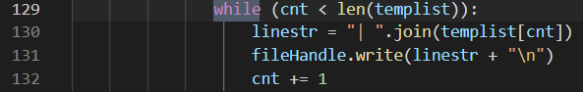

While the variable cnt is not equal to templist, the programme will return "True," and the programme will continue to display "|" and accept input and check until they are equal to each other, exiting the while loop.

### 3.2.4 Logical Operator

#### AND



The result will return “True” If all the “and” statements are fulfilled.

## 3.3 Control Structure

#### IF



#### The if Statement is used to make decisions in Python. It consists of a piece of code that only executes when the if statement's condition is true. The else line, which includes code for the else condition, is performed if the condition is false.

#### ELIF

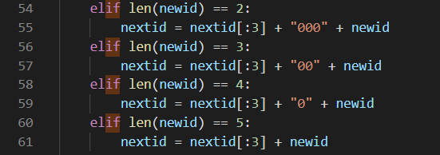

Elif is an acronym meaning "else if." It allows us to check for several expressions at once. If the if condition is False, the condition of the next elif block is examined, and so on. If all of the requirements are False, the body of else is executed.

## 3.4 Functions

|  |  |  |
| --- | --- | --- |
| Function name | Screenshot | Explanation |
| Getid |  | This function is used to get id for stuff. |
| Getid2 |  | This function is used to ger customer id. |
| Change-customer_password |  | This function is used to change customer password. |
| deposit |  | This function is used to deposit money into account. |
| Withdrawal |  | This function is used to withdraw money from account. |
| cosBalance |  | This function is used to to write down customers balance. |
| Check_stuff |  | This function is used to check all stuff existed. |
| Check_customer |  | This function is used to check all customers existed. |
| Create_stuff |  | This function is used to create new stuff account. |
| Create_customer |  | This function is used to create new customer account. |
| Adminaccess |  | This function is used to access login into admin account. |
| Customeraccess |  | This function is used to access customer account. |
| Main |  | This function is used to to access main menu to choose which account to log in.(Admin, stuff, customer) |
| Admin_option |  | This function is used to show all the options admin have.(create new stuff account) |
| Stuff_option |  | This function is used to show all the options stuff account has.(create new customer account or change password) |
| Customet_option |  | This function is used to show customer options where he/she can withdraw or deposit money into their savings or current account) |

## 3.5 File

### 3.5.1 Read



The module “r” is used in python to read data from certain files. In this image module “r” reads file called “data.txt”.

### 3.5.2 Append



The module “a” is used in python to append data to files. In this image module “a” automatically creates file called “customer_transaction.txt”.

### 3.5.3 Write



The module “w” is used in python to write data to files. In this image the module “w” writes data into file called “data.txt”.

## 3.6 Module

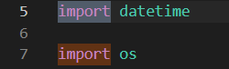

A module is a piece of ready-to-use code that can be loaded into our application to do certain tasks. The datetime and os module is imported, as illustrated in this image, to obtain the current day and assign it to the variable "today."

# 4.0 Sample of Input and Output

## 4.1 Menu – User

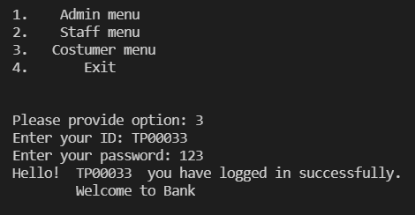

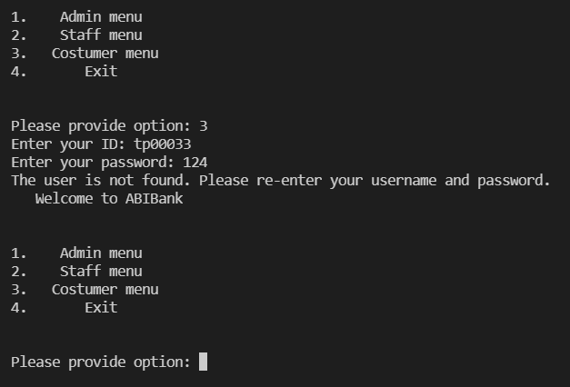

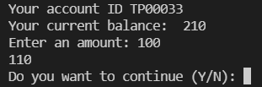



## 4.2 Menu – Stuff

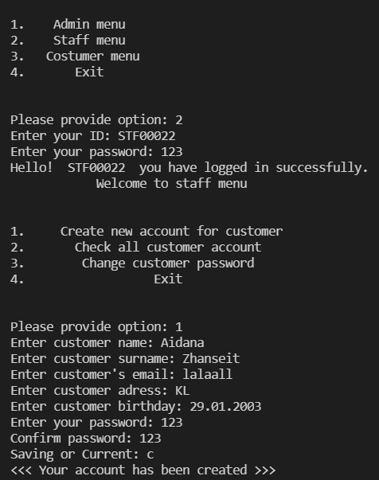

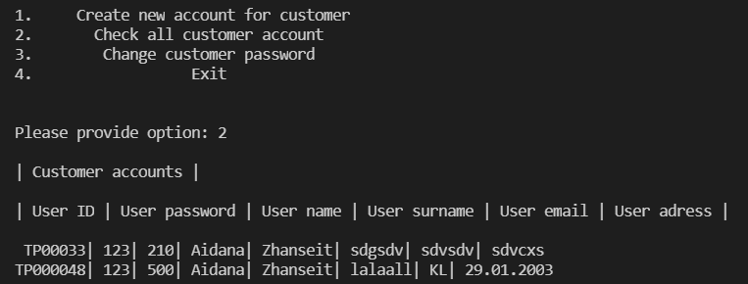

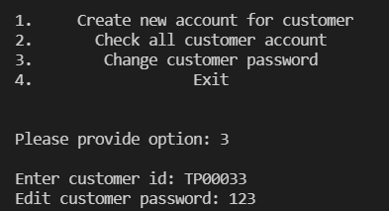

## 4.3 Menu – Admin

